Hadoop - Assignment 1

GUIDO VAN DIJK   
IT2B  
648539

GitHub Link: <https://github.com/guidovdijk/hadoop-assesment/>

12/05/2022

# Steps to take to execute:

The steps assume that the user already has the ml-100k folder on his machine and the python file will be added on the same path as the folder. If the folder is not present, please check the presentation of the second lecture on how to add it.

**Structure:**  
| …  
| - <name>.py  
| - ml-100k   
| - u.data

**Steps:**

1. Start the Virtual Environment with the image from Moodle
2. Start PuTTy
3. Login as root user – **su root**
4. Create a new python file in the root **touch <name>.py**
5. Open the file **vi <name>.py**
6. Copy the code from the repository
7. Paste it in the python file (“go into insert mode **i** > ”)
8. Save and quite **!wq**
9. Run the python file: **<name>.py -r hadoop --hadoop-streaming-jar /usr/hdp/current/hadoop-mapreduce-client/hadoop-streaming.jar ./ml-100k/u.data**

# Steps of the code

Steps in the code are shown in the file itself. It can also be read in the repository: <https://github.com/guidovdijk/hadoop-assesment/blob/main/main.py>

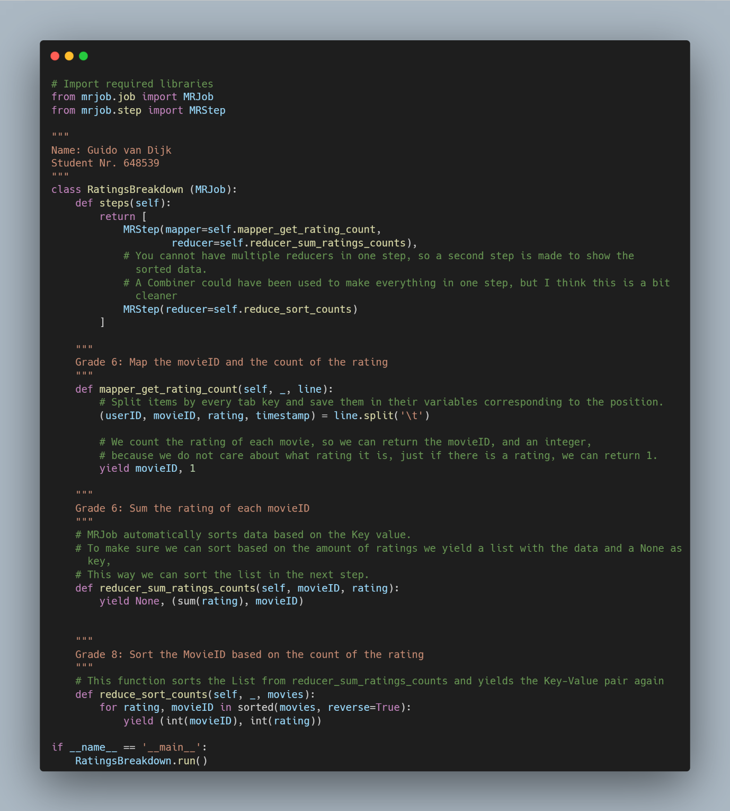

# Result of the code

